Identical Rhyme Couplets

🎯 What is Identical Rhyme Couplets
# Source: Chatgpt (GPT-4-turbo) at [8/2/2025]
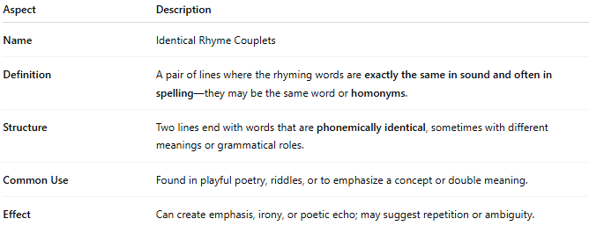
Aspect | Description
Name | Identical Rhyme Couplets
Definition | A pair of lines where the rhyming words are exactly the same in sound and often in spelling—they may be the same word or homonyms.
Structure | Two lines end with words that are phonemically identical, sometimes with different meanings or grammatical roles.
Common Use | Found in playful poetry, riddles, or to emphasize a concept or double meaning.
Effect | Can create emphasis, irony, or poetic echo; may suggest repetition or ambiguity.

✅ Example of Identical Rhyme in a Couplet
# Source: Chatgpt (GPT-4-turbo) at [8/2/2025]
He didn’t lie—he told the truth, no lie
And none could challenge him or ask him why
Here’s a clearer example with true identical rhyme:
The fair was held in open air so fair
She spun around with wind-blown hair so fair
- The word "fair" is repeated in both lines, maintaining identical sound and spelling.
Another example with homonyms:
He rose at dawn to smell the rose
And stood in awe, in thoughtful pose
- "rose" (verb) and "rose" (noun) = same pronunciation, different meanings → homonymic identical rhyme

